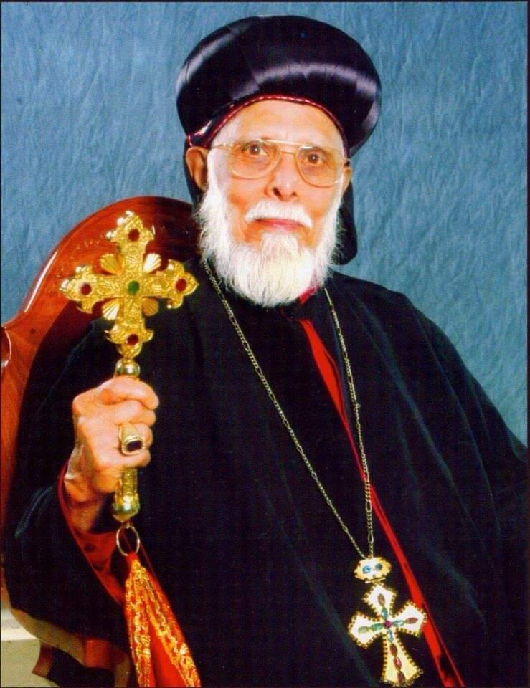
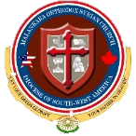
Malankara Orthodox Syrian Church
Diocese of South-West America
Mar Makarios Scholarship Award
3101 Hopkins Rd, Beasley, Texas – 77417
Email: marmakariosscholarship@gmail.com

2024 Vicar Recommendation Form

- Applicant’s Information (To Be Filled Out By The Applicant)

Full Name:
Mailing Address:
City: | State: | Zip Code:
Email Address: |  | Phone Number:
Home Parish Name & Address:
Parish City: | Parish State: | Parish Zip Code:

- Recommendation Letter from the Vicar (To be filled out by the Vicar)
Vicars: Please fill out the below info, date, sign & send it directly to the email above
Write, check or circle the appropriate answer (E = Excellent, VG = Very Good, G = Good, F = Fair

1 Are the Applicant’s family and the Applicant members of the parish in good standing?
2 Applicant’s loyalty and involvement in Parish activities (Circle one) E / VG / G / F
3 Applicant’s loyalty and dedication to the Malankara Orthodox Faith (Circle one) E / VG / G / F
4 Does the applicant participate in daily prayers and observe lent and fasting? (Circle one) E / VG / G / F
5 Attendance in regular worship services (Circle one) 75 to 100% 50 to 75% 25 to 50% Less than 25%
How active? Answer
6 Applicant’s Membership in Spiritual Organizations MGOCSM Youth Movement FOCUS Others
Regular member or office bearer? Answer
How active in Spiritual Organizations? Answer
7 Does the applicant participate in any Church Service groups? (Circle) Altar Assistant Choir Others
8 Participation in other Parish programs / Activities (Circle) Xmas Carol Celebrations Charities Volunteer Prog.
How active in each program / Activity?
Additional Comments on Activities:

- Comments & Recommendation
(Please exclude Sunday School and make the rest condensed)
(Please include the Applicant’s commitment, character, dedication, leadership qualities, etc.)

Vicar’s Name: | Phone Number:
Vicar’s Email:
Signature: | Date:

